My AI assistant (Mathi v0
My AI assistant (Mathi v0.1)

Purpose:
- My Personal assistant can keep my scheduled
- To notify me if something important ex - Mails, calls, social media and etc …

Terms:
- It should only run offline inside my own compute and it should only read my data and
- share it any thing outside with my permission only

Learning Guide

🚀 Phase 1: Understand the Basics (Week 1–2)
Before touching AI, you need just enough programming to not feel lost.

1. Learn Python (your foundation)
Start with:
- Variables, loops, functions
- Input/output
- Basic file handling
Use:
- Python
- VS Code (install this editor)
Good beginner platforms:
- freeCodeCamp
- Codecademy
- YouTube (search “Python for beginners full course”)
👉 Goal: Write simple programs like:
- calculator
- to-do list (console-based)

🧠 Phase 2: Learn Core Concepts of AI (Week 3–4)
Don’t dive too deep—just understand what’s happening.
Focus on:
- What is AI / Machine Learning
- What is Natural Language Processing (NLP)
- What APIs are (very important)
Key concept:
👉 You won’t build AI from scratch—you’ll use APIs from companies like OpenAI

🛠️ Phase 3: Build Your First Simple Assistant (Week 5–6)
Start very small.

Project 1: Text-based assistant
Your assistant should:
- Take input (user types)
- Respond using AI
Use:
- OpenAI API
Basic flow:
- User types: “What’s the weather?”
- Your Python script sends it to API
- API returns answer
- You print it
👉 This alone = your first AI assistant

🔊 Phase 4: Add Voice (Week 7–8)
Now make it feel like a real assistant.

Add:
- Speech-to-text (user speaks)
- Text-to-speech (assistant talks)
Libraries:
- speech_recognition
- pyttsx3
Now your assistant can:
- Listen 🎤
- Think 🤖
- Speak 🔊

📱 Phase 5: Give It Abilities (Week 9–12)
Make it useful.
Add features like:
- Open apps
- Set reminders
- Search Google
- Tell time/date
- Control basic system tasks
Example:
- “Open YouTube”
- “Set alarm for 7 AM”

🌐 Phase 6: Build Interface (Optional but Powerful)
Instead of a boring terminal:
Options:
- Web app → learn basic HTML/CSS
- Mobile app → use:
  - Flutter
  - or React Native

🧩 Phase 7: Make It Smarter
Now you evolve it:
- Add memory (store user preferences)
- Connect to apps (calendar, email)
- Use automation tools like:
  - Zapier

Python Installation guide
How Do You Install, Configure and Use Python in Your Local Environment?
In the last lesson, you learned what Python is and what you can do with it. Now, let's look into how you can set up Python on your local machine.

The easiest way to install Python on Windows and Mac is to download the installer from the official Python website. We'll also go over running Python on Linux later in this lesson.

Go to https://www.python.org/ and hover over "Downloads". A modal will appear showing the current version of Python for your operating system (OS).

We'll go over how to install Python on a computer running macOS first:

Click on the button showing the current version of Python (from the previous modal), and you'll start downloading a .pkg installation file automatically.
Once the .pkg installer is finished downloading, open it, then click "Continue" in the window that opens up.
Continue clicking the "Continue" button until you get to the "Installation Type" section. There, click the "Install" button.
Enter your password if necessary, then start the installation.
After that, you should get a congratulations message saying that Python has been successfully installed.
Click the "Close" button, and you're done!
You can verify the installation by opening up your terminal and running python --version or python3 --version.

You can also open the Python interpreter by running python or python3 in the terminal.

A terminal is a text-based interface that lets you interact with your computer by typing commands. Each operating system comes with a default terminal app. On macOS, you can use the Terminal app. On Windows, you can use Command Prompt or PowerShell. On Linux, each desktop environment has its own default terminal app, like GNOME Terminal or Konsole.

Note that, on some older macOS and Linux systems, python can be reserved for Python 2, while python3 is for Python 3 specifically. If you run python --version and see a version of Python 2 like Python 2.7.18, then it's possible that your OS relies on some software that was written in the older version of Python. If that's the case, you should use python3 to run your Python code going forward. Python 2 is end-of-life and should not be used for any new development.

To install Python on Windows, follow these steps:

Go to https://www.python.org/, and hover over “Downloads“. You should see a modal that says "Download for Windows" and a download button with the current version of Python.
Click on the version number, and you'll start downloading a Windows executable (.exe) file automatically.
Once you've finished downloading the Python installer for Windows, double-click on it, and follow the instructions.

When you see the option Add python.exe to Path, check that option, then click Install Now. Doing that will make things easier for you later.
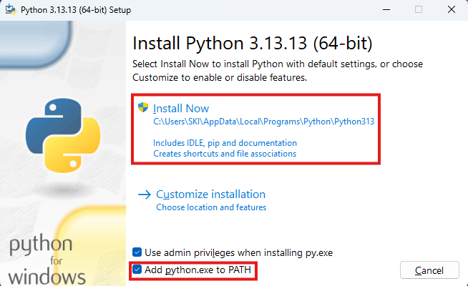

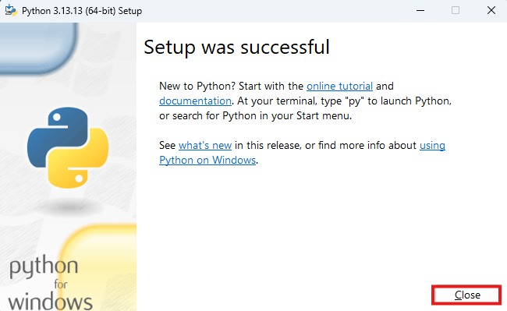

You can verify the installation by opening up a command line shell like PowerShell and running python --version. You can also open the Python interpreter by running python.

For Python on Linux, most major distros like Ubuntu, Debian, and Fedora come with Python.

Just open a terminal and run python --version, or python3 --version:

If either command doesn't show a version of Python, you can search for an installation package for your flavor of Linux at https://www.python.org, or search online for the recommended way to install Python for your distro.

Learnings
Weeks 1&2

Variables: In Python, you just write the name of the variable on the left, followed by the assignment operator, and the value you want to assign the variable on the right.

- Variable names can only start with a letter or an underscore (_), not a number.
- Variable names can only contain alphanumeric characters (a-z, A-Z, 0-9) and underscores (_).
- Variable names are case-sensitive — age, Age, and AGE are all considered unique.
- Variable names cannot be one of Python's reserved keywords such as if, class, or def.

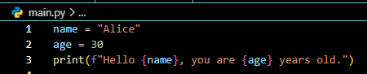
Here we can use f inside the parentheses decals all inside the double quotes as formatted string literals except the name & age inside the curly braces.

